**TSQL Homework 05**

**Question 1**

What is a table expression? Can you give a technical definition of a table expression?

**Answer**

A table expression is a named query expression that represents a valid relational table. You can use table expressions in a data-manipulation statements much like you use other tables. Expression is a piece of code that a computer evaluates to a value.

**Question 2**

In what SQL clause are derived tables (table valued subqueries) located?

**Answer**

Derived tables (also known as table subqueries) are defined in the FROM clause of an outer query. Their scope of existence is the outer query. As soon as the outer query is finished, the derived table is gone.

**Question 3**

Why can you refer to column aliases in an outer query that you defined in an inner table valued subquery?

**Answer**

The order of which they are processed. The From comes first.

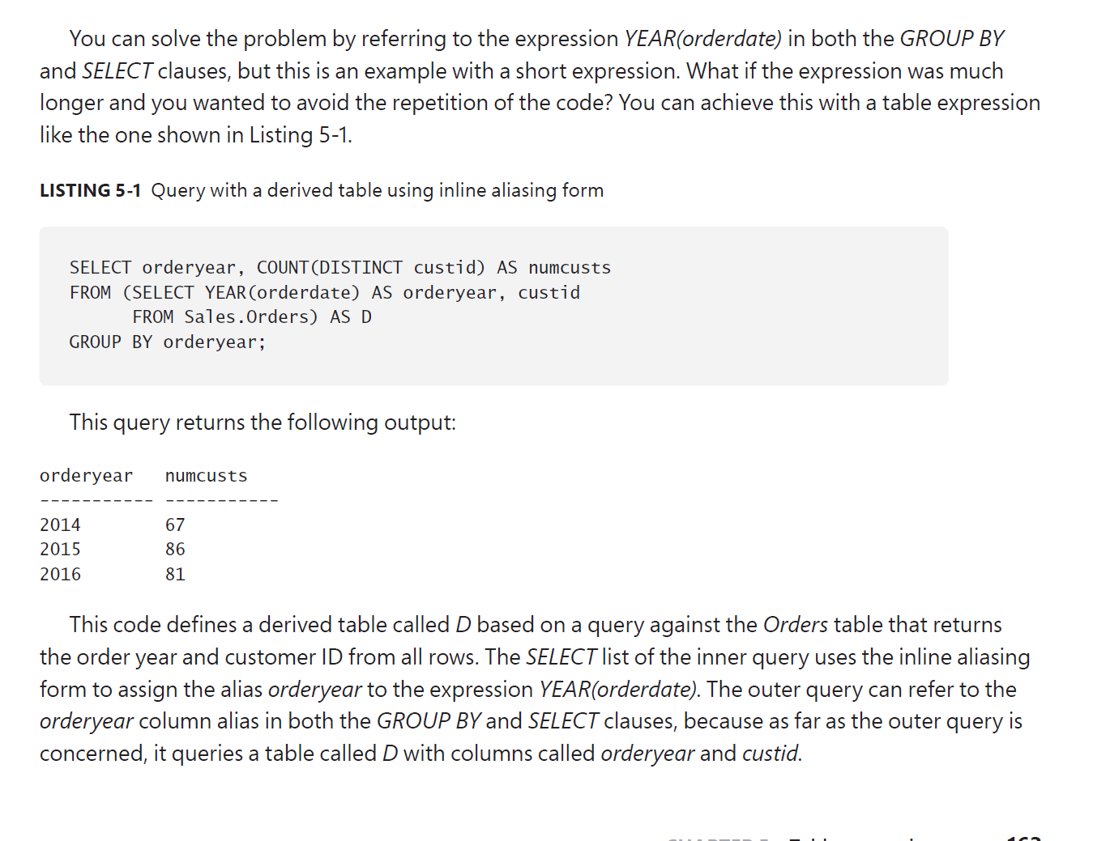

**Question 4**

What SQL key word defines a common table expression?

**Answer**

WITH is the keyword. CTE stands for common table expression. CTE’s are another standard form of table expression similar to derived tables, yet with a couple of important advantages.

**Question 5**

When using common table expressions, can a subsequent derived table use a table alias declared in a preceding table expression?

**Answer**

Yes, it can. Because the FROM clause is executed first.

**Question 6**

Can a main query refer to a previously defined common table expression by multiple aliases?

**Answer**

Yes, it can.

**Question 7**

In SQL, is a view a durable object?

**Answer**

Views and inline table-valued function (inline TVFs) are two types of table expressions whose definitions are stored as permanent object in the database, making them reusable.

**Question 8**

In a view, what does WITH CHECK OPTION do? Why is this important?

**Answer**

The purpose of CHECK OPTION is to prevent modifications through the view that conflict with the view’s filter.

**Question 9**

In a view, what does SCHEMABINDING do? Why is this important?

**Answer**

The SCHEMABINDING option is available to views and UDFs; it binds the schema of referenced objects and columns to the schema of the referencing object. It indicates that referenced objects cannot be dropped and that referenced columns cannot be dropped or altered.

**Question 10**

What is a table valued function?

**Answer**

Inline TVFs are reusable table expressions that support input parameters. In most respects, except for the support for input parameters, inline TVFs are similar to views. For this reason, I like to think of inline TVFs as parameterized views, even though they are not formally referred to this way.

**Question 11**

What does the APPLY operator do?

**Answer**

The APPLY operator is a powerful table operator. Like all table operators, APPLY is used in the FROM clause of a query. Like the JOIN table operator, APPLY performs its work in logical-query phases.

**Question 12**

What are the two forms of the APPLY operator? Give an example of each.

**Answer**

There are two supported types of APPLY: CROSS APPLY and OUTER APPLY. CROSS APPLY implements only one logical-query processing phase, whereas OUTER APPLY implements two. Examples got to page 180.